**Class 4 Assignment**

**Name:** Matan Reuven Tal

**Task 1:**

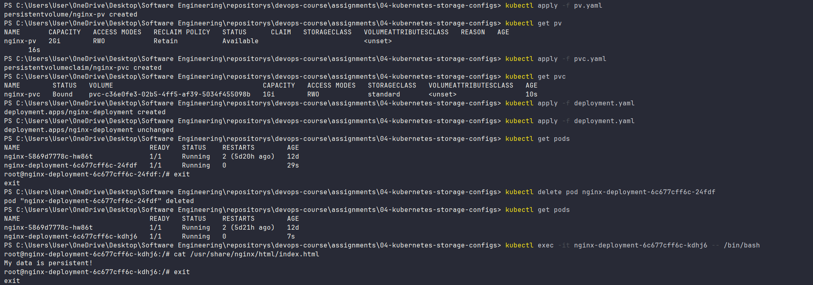

**Task 3:**

**Task 4:**

**Task 5:**

